OS Lab Report – Week 4

PES1201800366

Aditeya Baral

1. Write a C program to implement Shortest-Job-First scheduling algorithm.

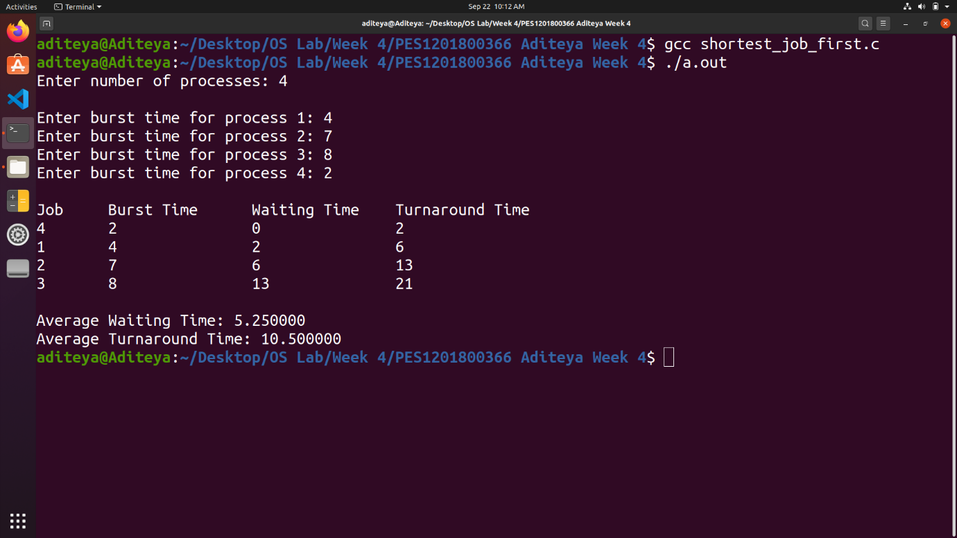

2. Write a C program to implement Priority Scheduling algorithm.

